**FAKE NEWS DETECTION USING MACHINE LEARNING**

**A PROJECT REPORT**

***Submitted by***

RISHI RAGHAV G - 21ADR038

ROHITH S J - 21ADR040

VIBEESH N - 21ADR059

VIGNESH T - 21ADR060

VIJAYAKUMARAN S – 21ADR061

**Team mentor:**

Ms. D. Sathya

***For***

**20ADT44 APPLIED MACHINE LEARNING**

**DEPARTMENT OF ARTIFICIAL INTELLIGENCE**



**KONGU ENGINEERING COLLEGE**

**(Autonomous)**

**PERUNDURAI ERODE – 638 060**

**MAY 2023**

**INTRODUCTION**

One of the consequences of technology is fake news. It is misinformation or misleading information offered as facts that can affect a person’s opinion. This false information has several goals; organizations can use it for financial purposes (e.g., Facebook pages used it to spread fake news leading to specific ads) or for political purposes. Compared with Google, Twitter, and webmail such as Yahoo and Gmail, Facebook is the worst media platform for pervasive fake news.

The definition of fake news is the information that pushes people to the wrong road. Fake news is spreading like a wildfire these days, and people are sharing it without confirming it. Fake news can be intimidating as they attract more audience than normal.People use them because this can be a very good marketing strategy. This fake information triggers fear and panic among people. Therefore, there is a need for ways to fact check news.

In this research, the best model to find whether the news is Real or Fake. For the first stage the dataset named fake_or_real_news is taken from the Kaggle. Then the dataset is preprocessed with proper preprocessing technique using Count vectorizer, TF-idf vectorizer, then the various models are created with several classification algorithms like Decision tree, Random forest, K-Nearest neighbor, Logistic Regression, Naïve Bayes, Support Vector machine. The best model is found through analysing the different metrices of those algorithms.

**PROBLEM STATEMENT**

* Now a days it is extremely difficult to decide whether the news we come across is real or not.
* This fake news had left an indelible mark on people and culture.
* Fake news play a major in election time.
* So to find whether the given information or news true or false using machine learning algorithm.
* The objective of this project is to examine the problems and reduce the spread of fake news.
* The fake news is a problem that is heavily affecting society and our perception of not only the media but also facts and opinions themselves.
* By using the artificial intelligence and the machine learning, the problem can be solved .
* So, our focus is to find which machine learning algorithm is best suitable for text dataset by comparing the performance of the models.

**PROPOSED SYSTEM**

The suggested framework is shown below. The publicly available dataset is used to train the system. To begin, clean up the data by deleting any superfluous characters or digits. After that, the Countvectorizer and TF-IDF vectorizer are utilized to extract features from the dataset. Then this cleaned dataset is used in different algorithms. Finally, the different metrices of classification algorithms are compared and the best model is found.

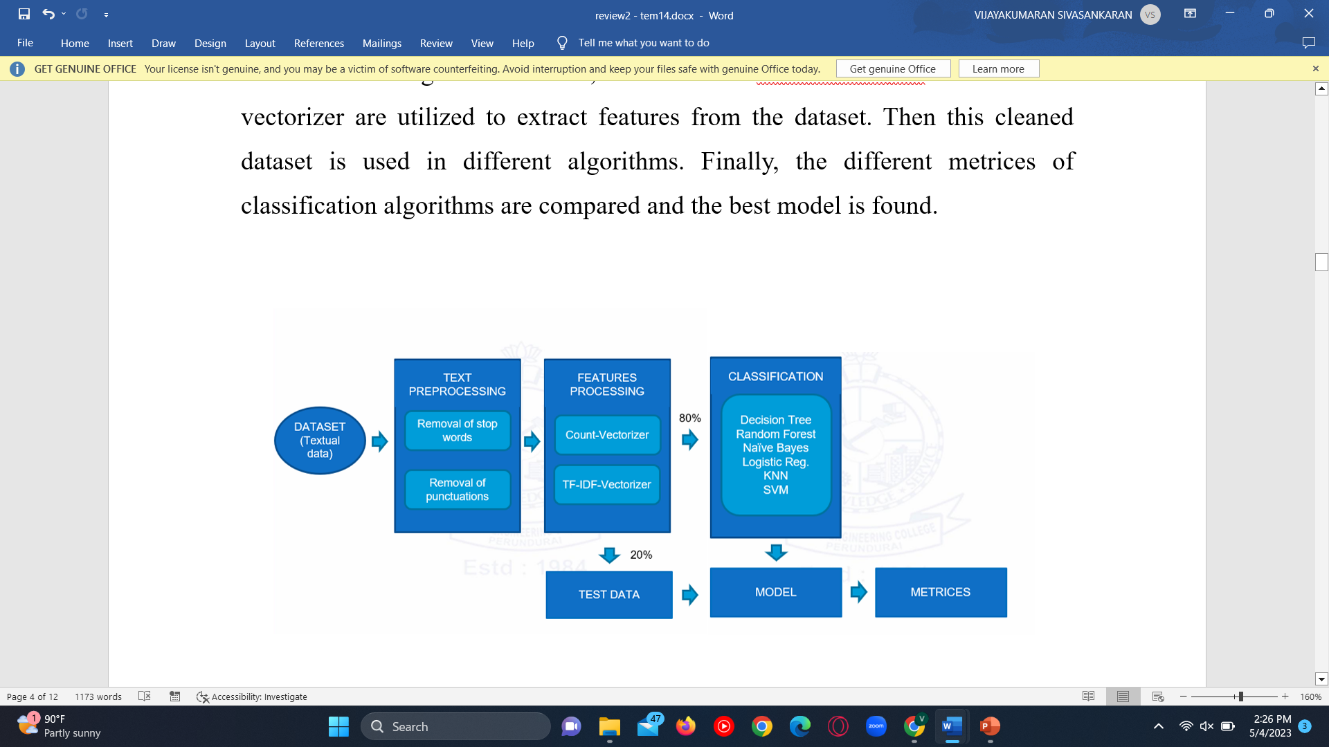

**FEATURE EXTRACTION :**

Text classification:

we are using TF-ID (Term Frequency & Inverse Document Frequency) is a powerful feature engineering technique used to identify the important words or more precisely rare words in the text data.

**ALGORITHMS USED**

The following algorithms were used :

* Random Forest
* Decision Tree
* Support Vector Machine (SVM)
* Kth Nearest Neighbour (KNN)
* Logistic Regression.
* Naïve Bayes

**Decision Tree classifier:**

A decision tree is a supervised machine learning algorithm, which is utilized for both classification and regression tasks. It has a hierarchical, tree structure, which consists of a root node, branches, internal nodes and leaf nodes.

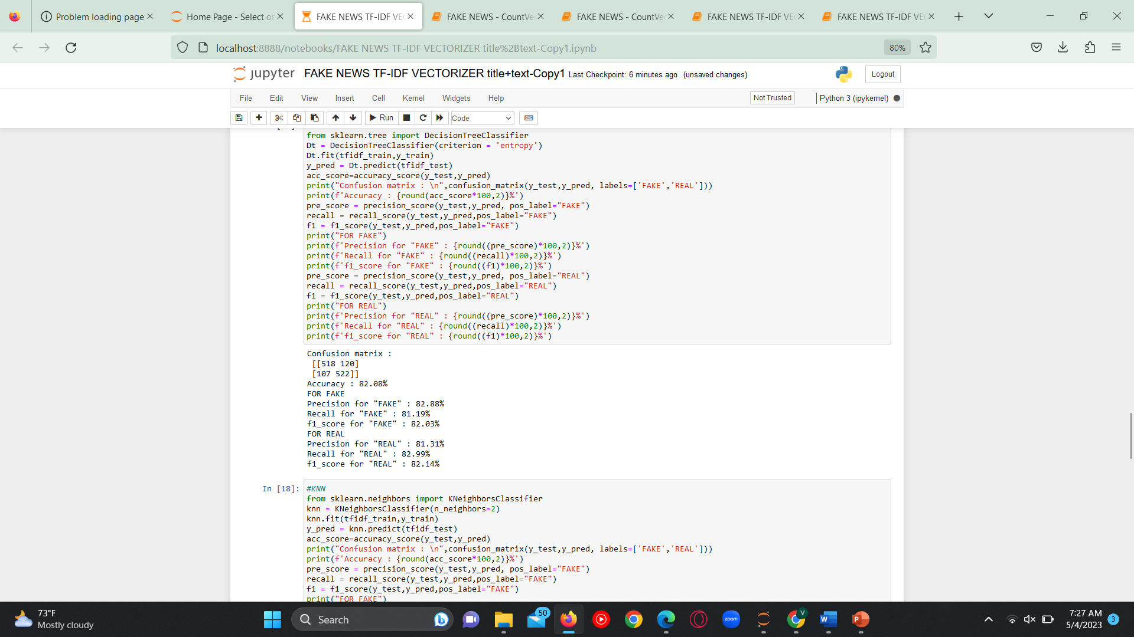

**K-Nearest Neighbors:**

The k-nearest neighbors algorithm, also known as KNN , is a supervised machine learning classifier, which used to make classifications or predictions.

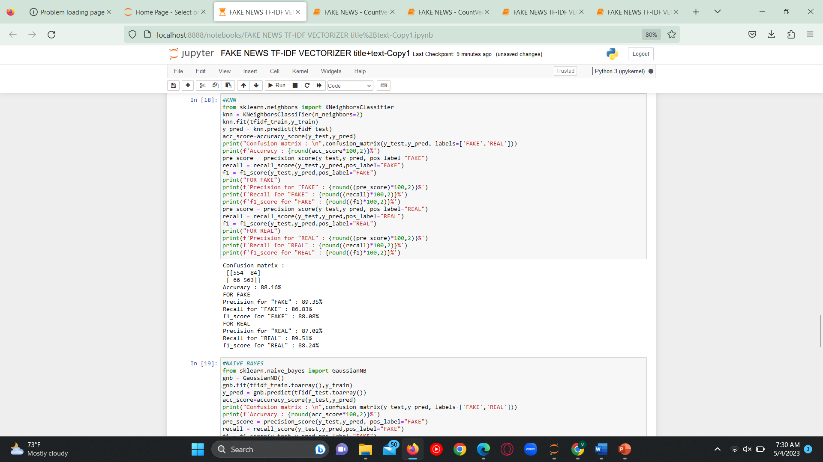

**Logistic Regression:**

It is a supervised machine learning method.Logistic regression is used to calculate or predict the probability of a binary (yes/no) event occurring.

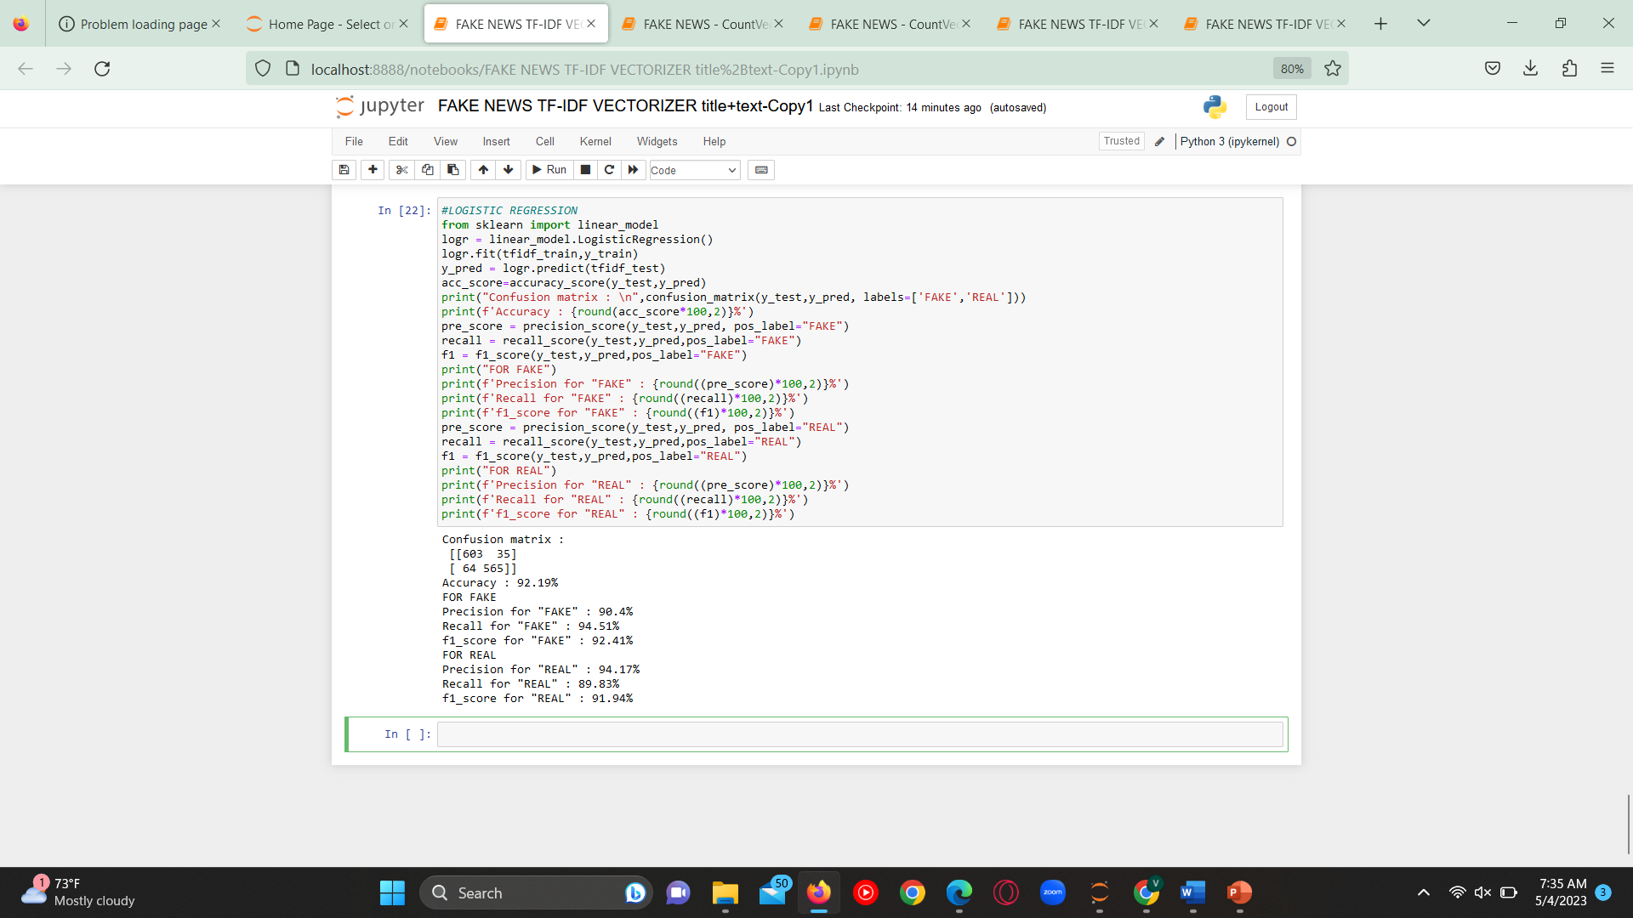

**Naïve Bayes classifier:**

The Naïve Bayes classifier is a supervised machine learning algorithm, which is used for classification tasks, like text classification.

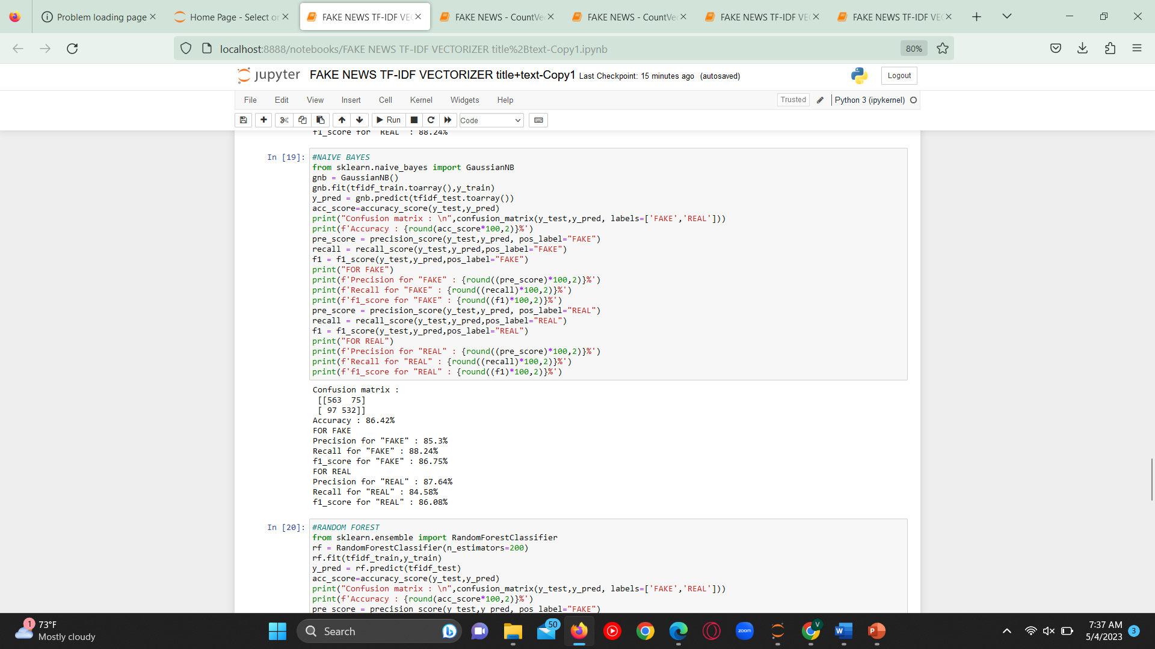

**Random Forest:**

Random Forest Algorithm is a supervised machine learning algorithm is used for Classification and Regression problems in Machine Learning.

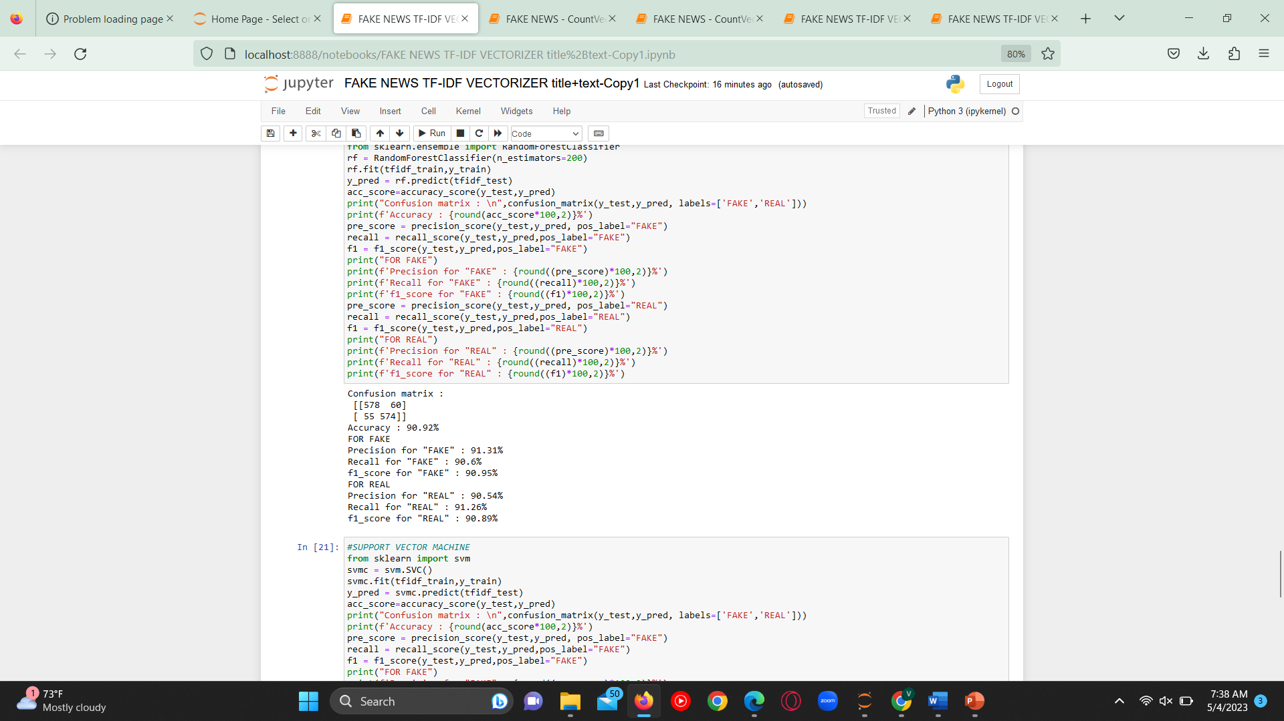

**Support Vector Machine:**

SVM is a supervised machine learning algorithm that works best on smaller datasets . Support Vector Machine, can be used for both regression and classification .But is best for classification.

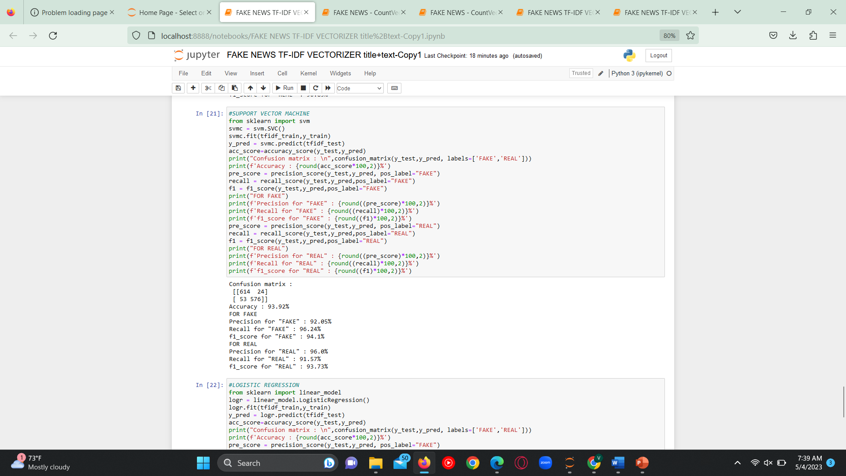

**Performance Metrics:**

Performance metrics are used to evaluate the performance of a classification model. We measured performance Accuracy, precision, recall and f1-score.

**Accuracy:**

The Accuracy is how we are relative to the right value.

Accuracy = number of correct predictions/total number of predictions

Accuracy equation is given by,

Accuracy = TP + TN /TP + TN + FP + FN

**Precision:**

Precision is how close the measurements are, which is given by

Precision = TP /(TP + FP)

**Recall:**

Recall (Sensitivity) is how many correctly actual positive is defined, is given by

Recall/Sensitivity/TPR = TP/ (TP + FN)

**F1-Score:**

The f1-score definition is that if the cost of false positives and false negatives varies, we require precision and recall, as given by

F1-Score = 2 × (Sensitivity × Precision) (Sensitivity + Precision)

where TP = True Positives, TN = True Negatives, FP = False Positives and FN = False Negatives.

|  |  |  |  |  |  |  |  |
| --- | --- | --- | --- | --- | --- | --- | --- |
| CountVectorizer | | | | | | | |
| Methods | Accuracy | Precision | | Recall | | F1 score | |
| Fake | Real | Fake | Real | Fake | Real |
| Decision Tree classifier | 81.45% | 81.03% | 80.8% | 80.9% | 82.24% | 81.45% | 81.45% |
| k-Nearest Neighbors | 80.33% | 78.27% | 82.64% | 83.7% | 76.7% | 80.72% | 79.62% |
| Logistic Regression | 91.55% | 91.81% | 91.0% | 91.38% | 91.57% | 91.59% | 91.28% |
| Naïve Bayes classifier | 82.56% | 88.12% | 78.33% | 75.55% | 89.67% | 81.35% | 83.62% |
| Random Forest | 90.61% | 91.0% | 90.22% | 90.28% | 90.94% | 90.64% | 90.58% |
| Support Vector Machine | 87.37% | 82.38% | 94.33% | 95.3% | 79.33% | 88.37% | 86.18% |

**COMPARISON :**

|  |  |  |  |  |  |  |  |
| --- | --- | --- | --- | --- | --- | --- | --- |
| CountVectorizer (title+text) | | | | | | | |
| Methods | Accuracy | Precision | | Recall | | F1 score | |
| Fake | Real | Fake | Real | Fake | Real |
| Decision Tree classifier | 80% | 81.03% | 79.22% | 79.0% | 81.24% | 80.0% | 80.22% |
| k-Nearest Neighbors | 81.22% | 79.94% | 82.64% | 83.7% | 78.7% | 81.78% | 80.62% |
| Logistic Regression | 91.32% | 91.64% | 91.0% | 91.07% | 91.57% | 91.35% | 91.28% |
| Naïve Bayes classifier | 83.03% | 88.11% | 79.07% | 76.65% | 89.51% | 81.98% | 83.97% |
| Random Forest | 90.69% | 90.62% | 90.75% | 90.91% | 90.46% | 90.77% | 90.61% |
| Support Vector Machine | 88.0% | 83.2% | 94.58% | 95.45% | 80.45% | 88.91% | 86.94% |

**CONCLUSION :**

As the result, the Logistic Regression has the highest accuracy of 91.55% by using the Count vectorizer in which the input feature has both the title and the text content of the specific new. So we are selecting the Logistic Regression as our base model. Using this model we can predict the fake news with maximum Accuracy.

**REFERENCE :**

1. <https://towardsdatascience.com/predicting-fake-news-using-nlp-and-machine-learning-scikit-learn-glove-keras-lstm-7bbd557c3443>
2. <https://sist.sathyabama.ac.in/sist_naac/documents/1.3.4/b.e-cse-batchno-214.pdf>
3. <https://www.hindawi.com/journals/complexity/2020/8885861/>
4. D. Keskar, S. Palwe, and A. Gupta, Fake News Classification on Twitter Using Flume, N-Gram Analysis, and Decision Tree Machine Learning Technique. Singapore: Springer, 2020, pp. 139–147, doi: 10.1007/978-981-15-0790-8_15.
5. A. Bali, M. Fernandes, S. Choubey, and M. Goel, ‘‘Comparative performance of machine learning algorithms for fake news detection,’’ 2019, doi: 10.1007/978-981-13-9942-8_40.
6. K. Shu, D. Mahudeswaran, S. Wang, D. Lee, and H. Liu, ‘‘FakeNewsNet: A data repository with news content, social context, and spatiotemporal information for studying fake news on social media,’’ Big Data, vol. 8, no. 3, pp. 171–188, Jun. 2020, doi: 10.1089/big.2020.0062.
7. L. Wu and H. Liu, ‘‘Tracing fake-news footprints: Characterizing social media messages by how they propagate,’’ in Proc. 11th ACM Int. Conf. Web Search Data Mining, Feb. 2018, pp. 637–645, doi: 10.1145/3159652.3159677.
8. J. Zhang, B. Dong, and P. S. Yu, ‘‘FAKEDETECTOR: Effective fake news detection with deep diffusive neural network,’’ 2018, arXiv:1805.08751.
9. S. Gilda, ‘‘Notice of violation of IEEE publication principles: Evaluating machine learning algorithms for fake news detection,’’ in Proc. IEEE 15th Student Conf. Res. Develop. (SCOReD), Dec. 2017, pp. 110–115, doi: 10.1109/SCORED.2017.8305411.
10. H. Ko, J. Y. Hong, S. Kim, L. Mesicek, and I. S. Na, ‘‘Human-machine interaction: A case study on fake news detection using a backtracking based on a cognitive system,’’ Cognit. Syst. Res., vol. 55, pp. 77–81, Jun. 2019, doi: 10.1016/j.cogsys.2018.12.018.
11. C.-S. Atodiresei, A. Tănăselea, and A. Iftene, ‘‘Identifying fake news and fake users on Twitter,’’ Proc. Comput. Sci., vol. 126, pp. 451–461, Jan. 2018, doi: 10.1016/j.procS.2018.07.279. [17] J. Pan, S. Pavlova, C. Li, N. Li, Y. Li, and J. Liu, ‘‘Content based fake news detection using knowledge graphs,’’ in Proc. 17th Int. Semantic Web Conf., Monterey, CA, USA, Oct. 2018, doi: 10.1007/978-3-030-00671-6_39.
12. M. Potthast, J. Kiesel, K. Reinartz, J. Bevendorff, and B. Stein, ‘‘A stylometric inquiry into hyperpartisan and fake news,’’ in Proc. 56th Annu. Meeting Assoc. Comput. Linguist. Proc. Conf. (ACL), vol. 1, 2018, pp. 231–240, doi: 10.18653/v1/p18-1022